DDR subsystem

General Description
DDR subsystem has following features:
- Supported SDRAM types include:
DDR4
LPDDR3
DDR3
DDR3L
DDR3U
- Supported SDRAM speed include:
DDR4 2400Mbps
LPDDR3 2133Mbps
DDR3 2133Mbps
DDR3L 1866Mbps
DDR3U 1600Mbps
- 64/32/16bits configurable SDRAM data width
- Storage volume supported:
16GB for 64bits data width
8GB for 32bits data width
4GB for 16bits data width
- Inline ECC supported
- Programmed supported 1T or 2T timing
- 6 axi ports
- QOS supported
- SSC(Spread Spectrum clock) supported

Architecture
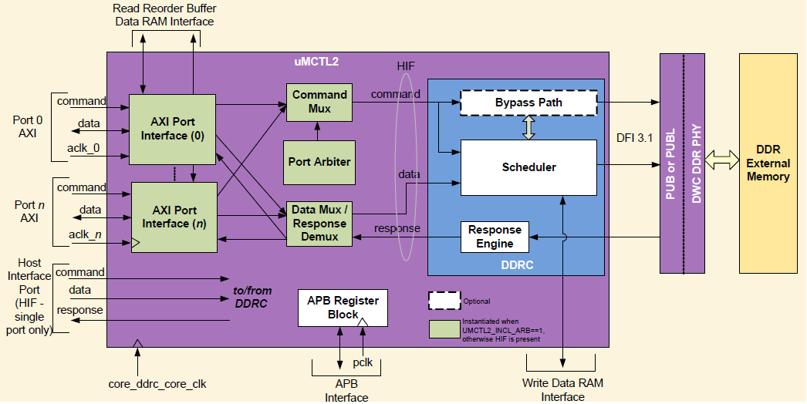
Figure : DDR subsystem Architecture

Functional description
DDR subsystem contains two parts, DDR controller and DDR PHY. DDR controller has six axi ports which connect to axi masters through axi bus. DDR controller receives transactions from axi masters. These transactions are queued internally and scheduled for access in order to SDRAM while satisfying SDRAM protocol timing requirements, transaction priorities, and dependencies between the transactions. DDR PHY provides an interface between the controller and external SDRAM devices. DDR controller communicate with DDR PHY through FDI interface.

